Chapter Four

SYSTEM DESCRIPTION

4.1. INTRODUCTIONS

The new proposed system named ‘DUCE Information Technology Forums with Alumni Based on content filtering’ is a computer-based web application which enables users to share knowledge and experience with each other.

The system provides:

* Users to have rich in information profile and manage their profile.
* Users including gusts can view user profile and members
* Users can ask question and are able to answer different questions
* Users can create forums and also give their ideas on forums
* Users can read, like and comment blog post and announcement.

This section of the document is aimed to describe the new system and its major functions in detail. The section also provides major navigation pages with their corresponding outputs and layouts in preferred format and describes the system architecture including the database, the server and the front-end framework.

4.1.1. ESSENTIAL NAVIGATIONS

DUCE Information Technology Forums with Alumni Based on content filtering is a computer-based web page, and has multiple pages navigated by the user. In general, there are four main pages, namely

* Guest page for guests who have no account, and only see the members of the system
* Basic user page where registered users other than administrator views and moderator views
* Moderators page where registered users with Moderator privilege have access to all other than administrator view
* Administrator page for administrators

**4.2. User guest page**

**4.2.1 Gust pages**

**Gust Dashboard**

This page enables both registered and unregistered users to see members profile and the gust page. The page as shown in the figures below have a gust page and members link.

**View Members**

In this page all users can view members and if they want, they can also see detail profile of a member.

**User Profile**

In this page a selected single user will be displayed

**4.2.2User page**

**User Login page**

This enables the users to login to their account by entering required inputs:

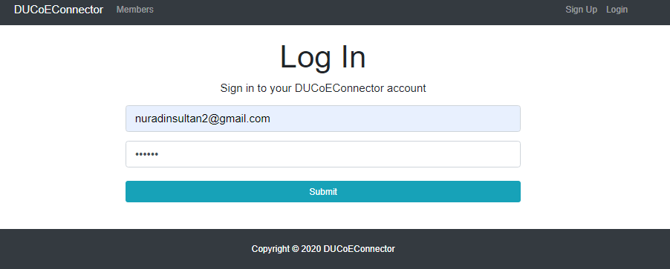

4.3 MERN stack

**What is the MERN Stack?**

A stack is the combination of technologies used to create a web application. Any web application will be made using multiple technologies (frameworks, libraries, databases etc).

The MERN stack is a JavaScript stack that’s designed to make the development process smoother. MERN includes four open-source components: MongoDB, Express, React, and Node.js. These components provide an end-to-end framework for developers to work in.

### 4.3.1 A Closer Look at MERN Stack Components

### 1.MongoDB: A cross-platform document database

### MongoDB is a NoSQL (non-relational) document-oriented database. While conventional relational databases have a typical schema design based on columns and tables, MongoDB is schema-less. Data is stored in flexible documents with a JSON (JavaScript Object Notation)-based query language. The content, size, and number of fields in the documents can differ from one to the next. This means that the data structure to be changed over time. MongoDB is known for being flexible and easy to scale.

2. **Express: A back-end web application framework**

Express is a web application framework for Node.js, another MERN component. Instead of writing full web server code by hand on Node.js directly, developers use Express to simplify the task of writing server code. There’s no need to repeat the same code over and over, as you would with the Node.js HTTP module. The Express framework is designed for building robust web applications and APIs. It’s known for its fast speed and minimalist structure, with many features available as plugins.

**3. React: A JavaScript library for building user interfaces**

React was originally created by a software engineer at Facebook, and was later open-sourced. It is maintained by Facebook, as well as a community of development companies and individual developers. The React library can be used for creating views rendered in HTML. React views are declarative. This means that developers don’t have to worry about managing the effects of changes in the view’s state (the object that determines how components behave) or changes in the data. Instead of relying on templates to automate the creation of repetitive HTML or DOM (Document Object Model) elements, React uses a full-featured programming language (JavaScript) to construct repetitive or conditional DOM elements. With React, the same code can run on both the server and the browser.

**4. Node.js: A cross-platform JavaScript runtime environment**

Node.js was initially built for Google Chrome, and later open-sourced by Google in 2008. It is built on Chrome’s V8 JavaScript engine. It’s designed to build scalable network applications, and can execute JavaScript code outside of a browser.Node.js works without an enclosing HTML page, instead using its own module system based on CommonJS, to put together multiple JavaScript files.

**The Benefits of the MERN Stack**

The main advantage for developers using the MERN stack is that every line of code is written in JavaScript. This is a programming language that’s used everywhere, both for client-side code and server-side code. With one language across tiers, there’s no need for context switching.

For tech stack with multiple programming languages, developers have to figure out how to interface them together. With the JavaScript stack, developers only need to be proficient in JavaScript and JSON. Overall, using the MERN stack enables developers to build highly efficient web applications.